**Embedded systems**



**Student: July Trendafilov**

**Class: T3-DB   
Docent: René Bakx  
Version: 0.1  
Date: 15-09-2022**

Contents

Summary 3

Rotary Encoder 3

LEDs 4

Low power 4

Interrupts 6

Serial Monitor 7

Conclusion 8

Bibliography 8

# Summary

This document serves as a PoC (Proof of concept) for the GPIO and EXTI registers using CMSIS. In this assignment a rotary encoder and 2 LEDs are used to proof the concept. Manuel has helped me with some of this assignment.

# Rotary Encoder

The function of the rotary encoder is to register left or right turns. The setup of this encoder is as follows:

We need two pins for the CLK and DT on the NUCLEO board. We must set both as input and remove the pull up and pull down as the rotary encoder has its own pull up. To debounce the rotary encoder, two capacitors of 100nF are used on the input pins which are connected to ground.

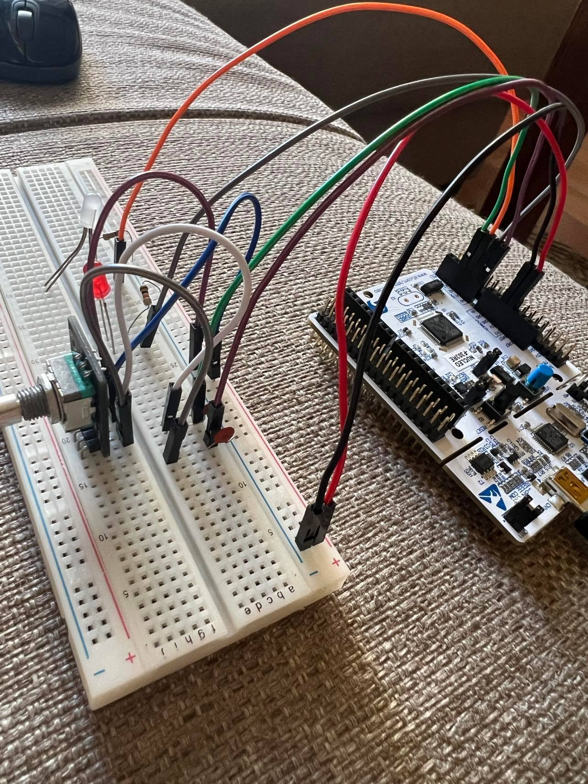

# LEDs

In this assignment two LEDs are turned on when either the encoder is turned left or right. To set up the LEDs we use this code:

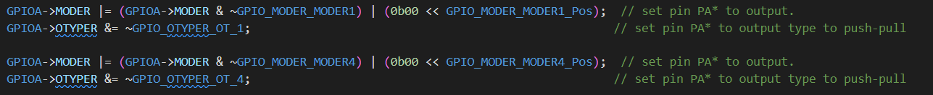

With the MODER register we set PA1 to output and then with OTYPER the type of output to push-pull (commented in code). We do the same thing for PA4 (the other LED). In the circuit 2 resistors must be used to keep the LED safe (lower amps).

# Low power

To achive low power, every time we are returned to the main loop from the Interrupt handler, the main loop enters WFI() to wait for another interrupt. This way we ensure that the power is low when there are no actions (interrupts).



The multimeter give the following output when the MC is in low power mode from WFI:

And when the interrupt is handled the MC gives higher usage:

# Interrupts

For the interrupt part, an interrupt is set to pin CLKwith the following setup and EXTI_Handler:

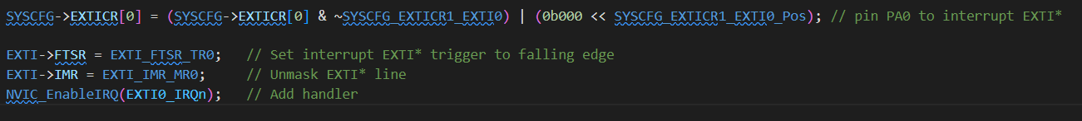

We connect the interrupt to the pin where CLK (PA0) is. Then weset the trigger to falling edge as the encoder has internal pullup. The interrupt must be unmasked to be handled directly and optionally add a handler to the interrupt. Our interrupt is as follows:

In the interrupt we first we reset the interrupt flag in order for the interrupt to appear again. Then we read the DT pin and check if it is HIGH. If it is HIGH we are rotating clockwise, else we are rotating counter-clockwise. This is because the interrupt is on CLK and then we check if DT is low or high. If we rotate left one LED lights up, else the other one. Only one LED is lid by the time. The LEDs are also a form of testing the direction of the encoder.

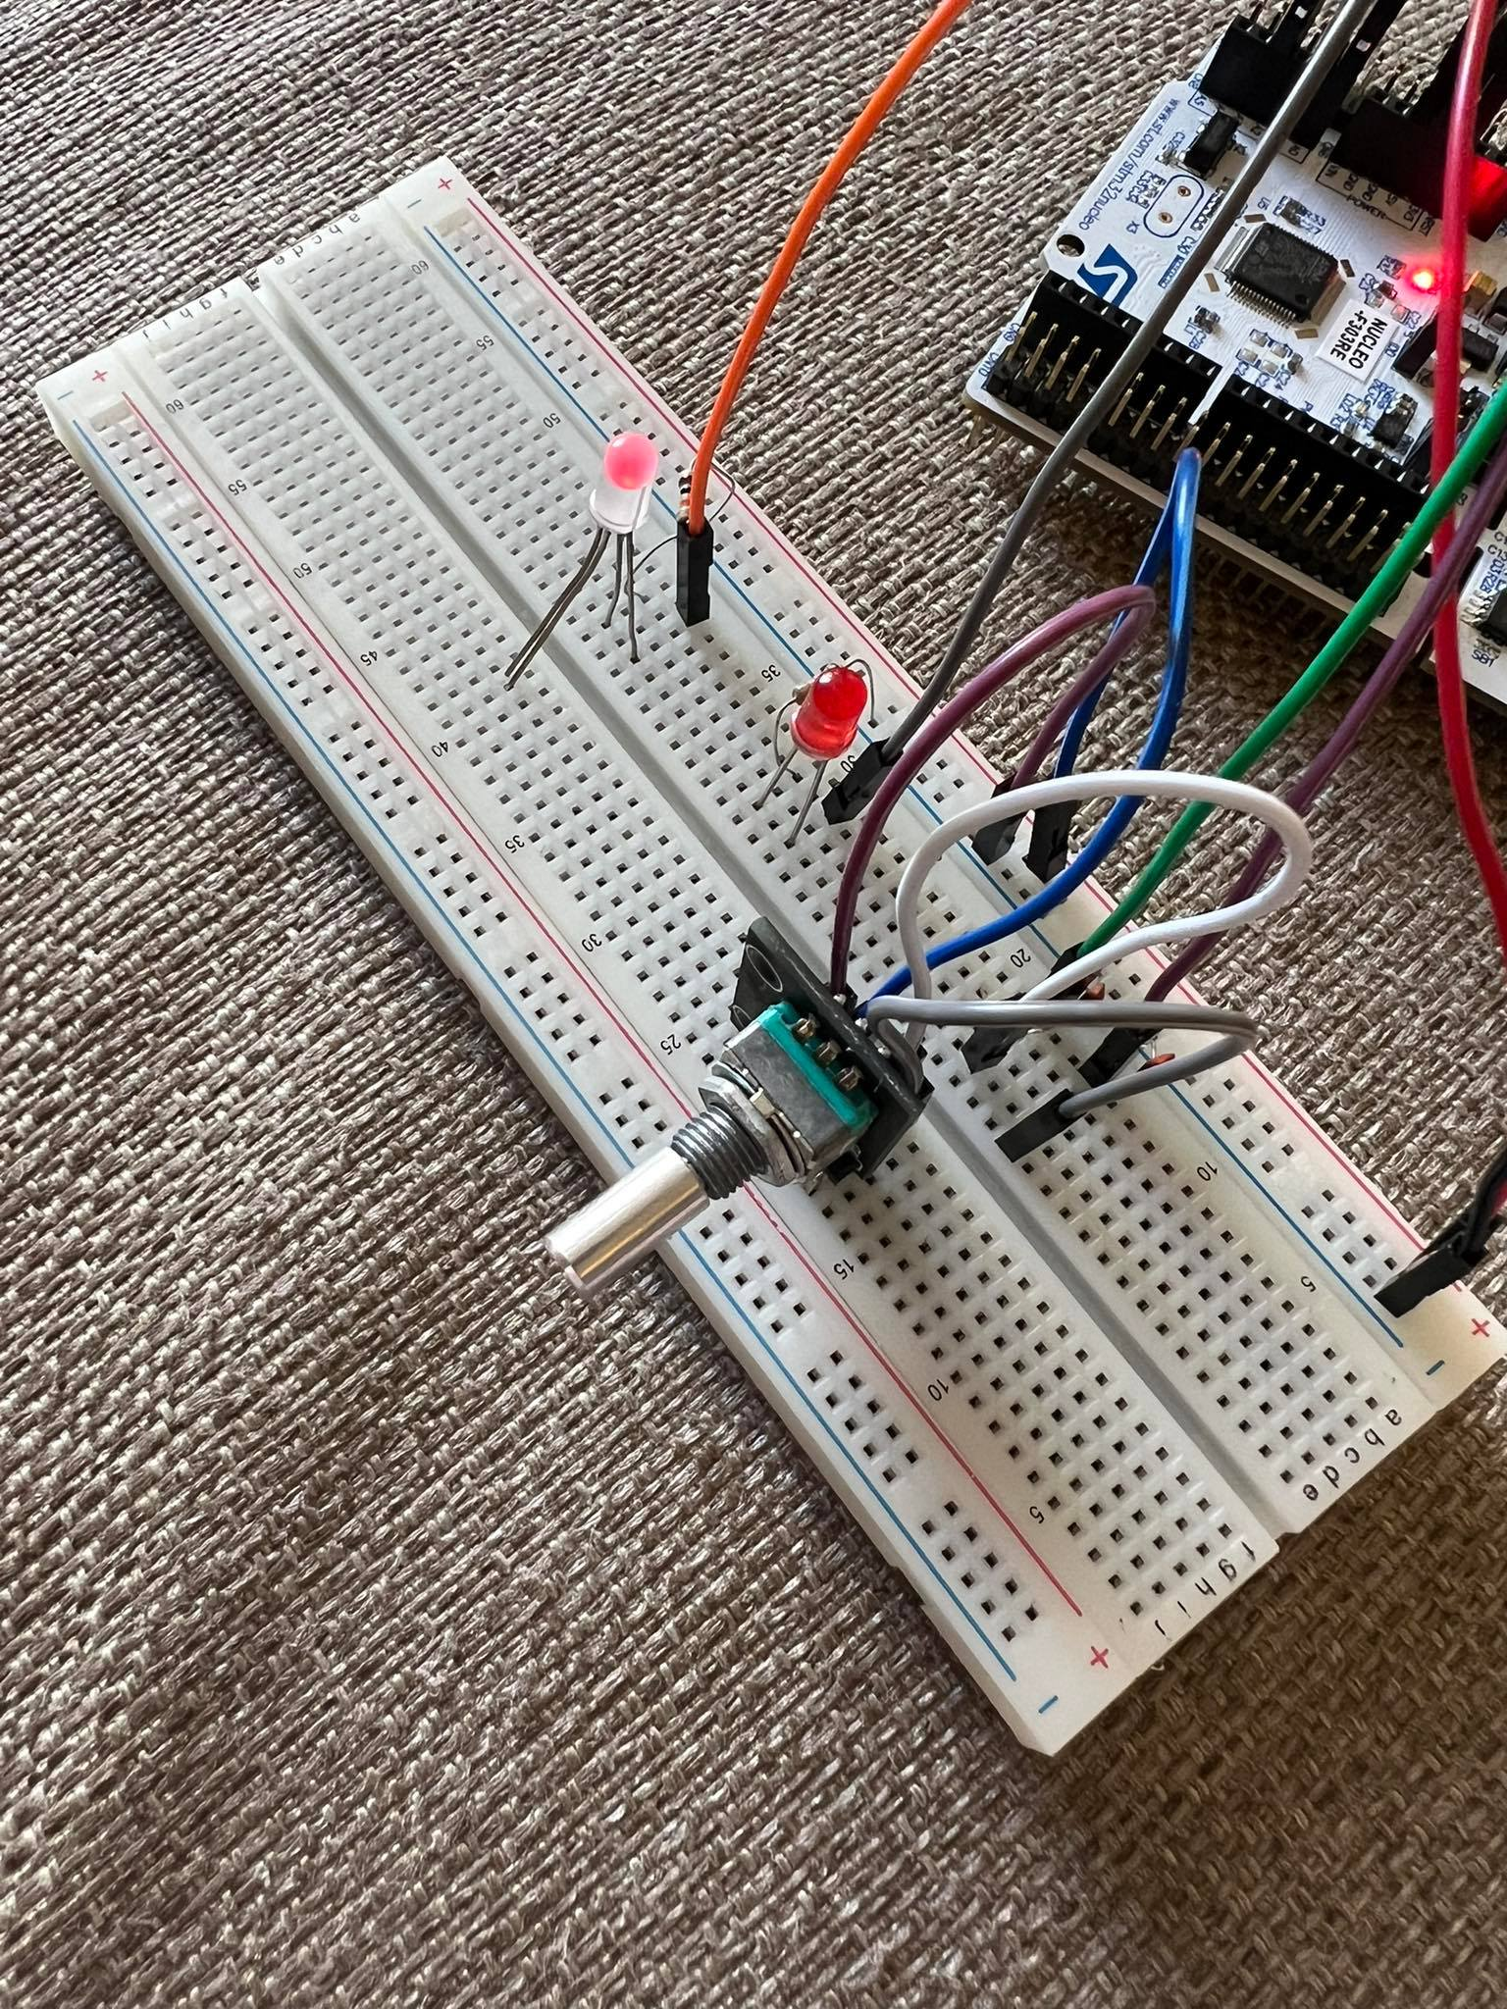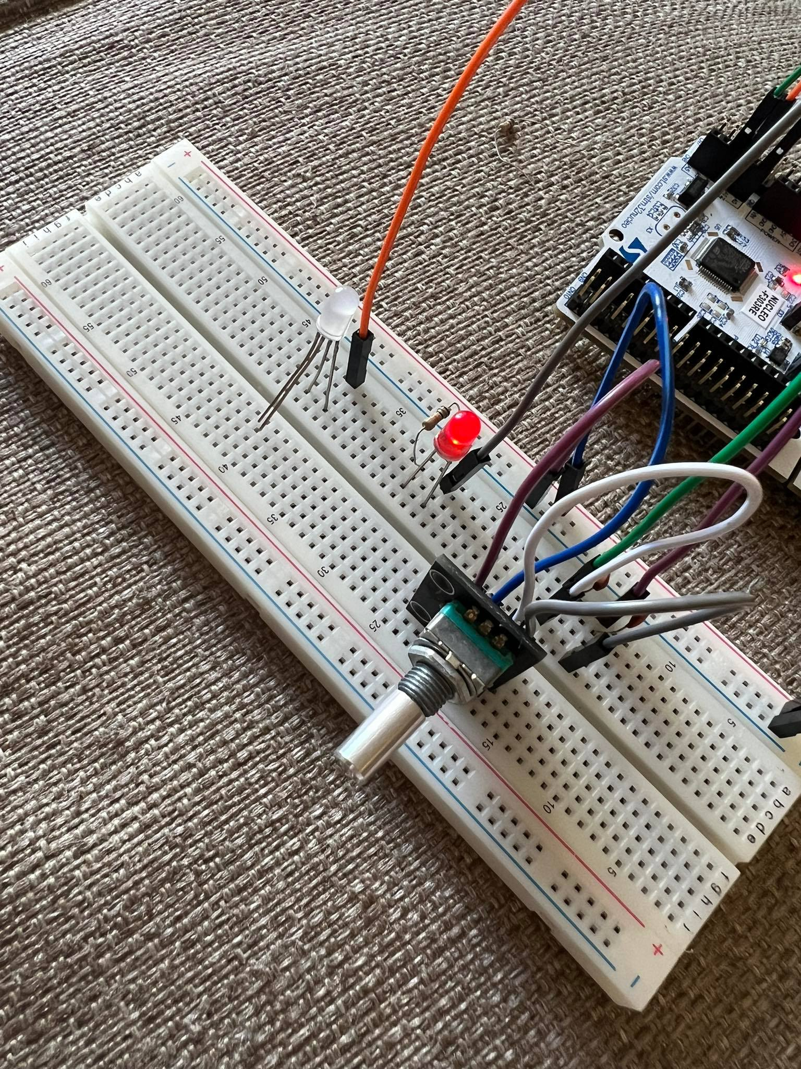

Because the RGB LED is a compound component with three LEDs I am using only the RED one by connecting only ground and the pin of the Red Led.

# Serial Monitor

To make sure rotations are registered, every time we have an interrupt we send the direction in the serial monitor (I am using Termite).

# Conclusion

In this assignment I have learned to control a rotary encoder and LEDs on the Nucleo board and manipulate the GPIO pins with the CMSIS. Furthermore, I have learned to use and handle interrupts and debug my application using the serial monitor. To ensure low power I learned how to set the board into low power mode using commands.The tests are done in a Lab and have the necessary parts documented. With this the PoC is made.

# Bibliography

Bakx, R. (2022). Opgehaald van GitLab: https://git.fhict.nl/technology/t-sem3-db/-/tree/master/embedded-systems/Presentations

ST. (sd). Opgehaald van Reference manual: https://www.st.com/resource/en/reference_manual/dm00043574-stm32f303xb-c-d-e-stm32f303x6-8-stm32f328x8-stm32f358xc-stm32f398xe-advanced-arm-based-mcus-stmicroelectronics.pdf

*Wikipedia*. (sd). Opgehaald van https://www.wikipedia.org